Task Description #1 (Privacy &amp; Security in File Handling)
Task: Use an AI tool to generate a Python script that stores user data (name, email, password) in a file.
PROMPT:
Create a simple Python program that stores a user's name, email, and password in a text file.
First, show the password being stored as plain text. Then explain the privacy and security risks of storing passwords this way.
Finally, modify the program to securely store the password using hashing instead of plain text. Explain what was changed and why it is safer.
CODE:
"""Password storage demonstration.

The first example is intentionally insecure: it writes the password directly
to a text file. Do not use this approach in real applications.
"""

from getpass import getpass
from hashlib import pbkdf2_hmac
from pathlib import Path
from secrets import token_bytes

def store_plaintext(name: str, email: str, password: str) -> None:
"""Insecure example: stores and displays the password as plain text."""
Path("users_plaintext.txt").write_text(
f"Name: {name}\nEmail: {email}\nPassword: {password}\n",
encoding="utf-8",
)
print(f"Plain-text password stored: {password}")

def store_securely(name: str, email: str, password: str) -> None:
"""Store a salted, slow password hash instead of the password itself."""
salt = token_bytes(16)
password_hash = pbkdf2_hmac("sha256", password.encode(), salt, 600_000)
Path("users_secure.txt").write_text(
f"Name: {name}\nEmail: {email}\n"
f"Salt: {salt.hex()}\nPassword hash: {password_hash.hex()}\n",
encoding="utf-8",
)
print("Secure record stored; the original password was not written.")

if __name__ == "__main__":
name = input("Name: ")
email = input("Email: ")
password = getpass("Password: ")

# Demonstration only. Plain-text files expose passwords to anyone who can
# read them, and a leak can enable account takeover and password reuse attacks.
store_plaintext(name, email, password)

# Safer replacement: a unique salt prevents identical-password matches,
# while PBKDF2's cost makes guessing attacks substantially slower.
store_securely(name, email, password)

OUTPUT:
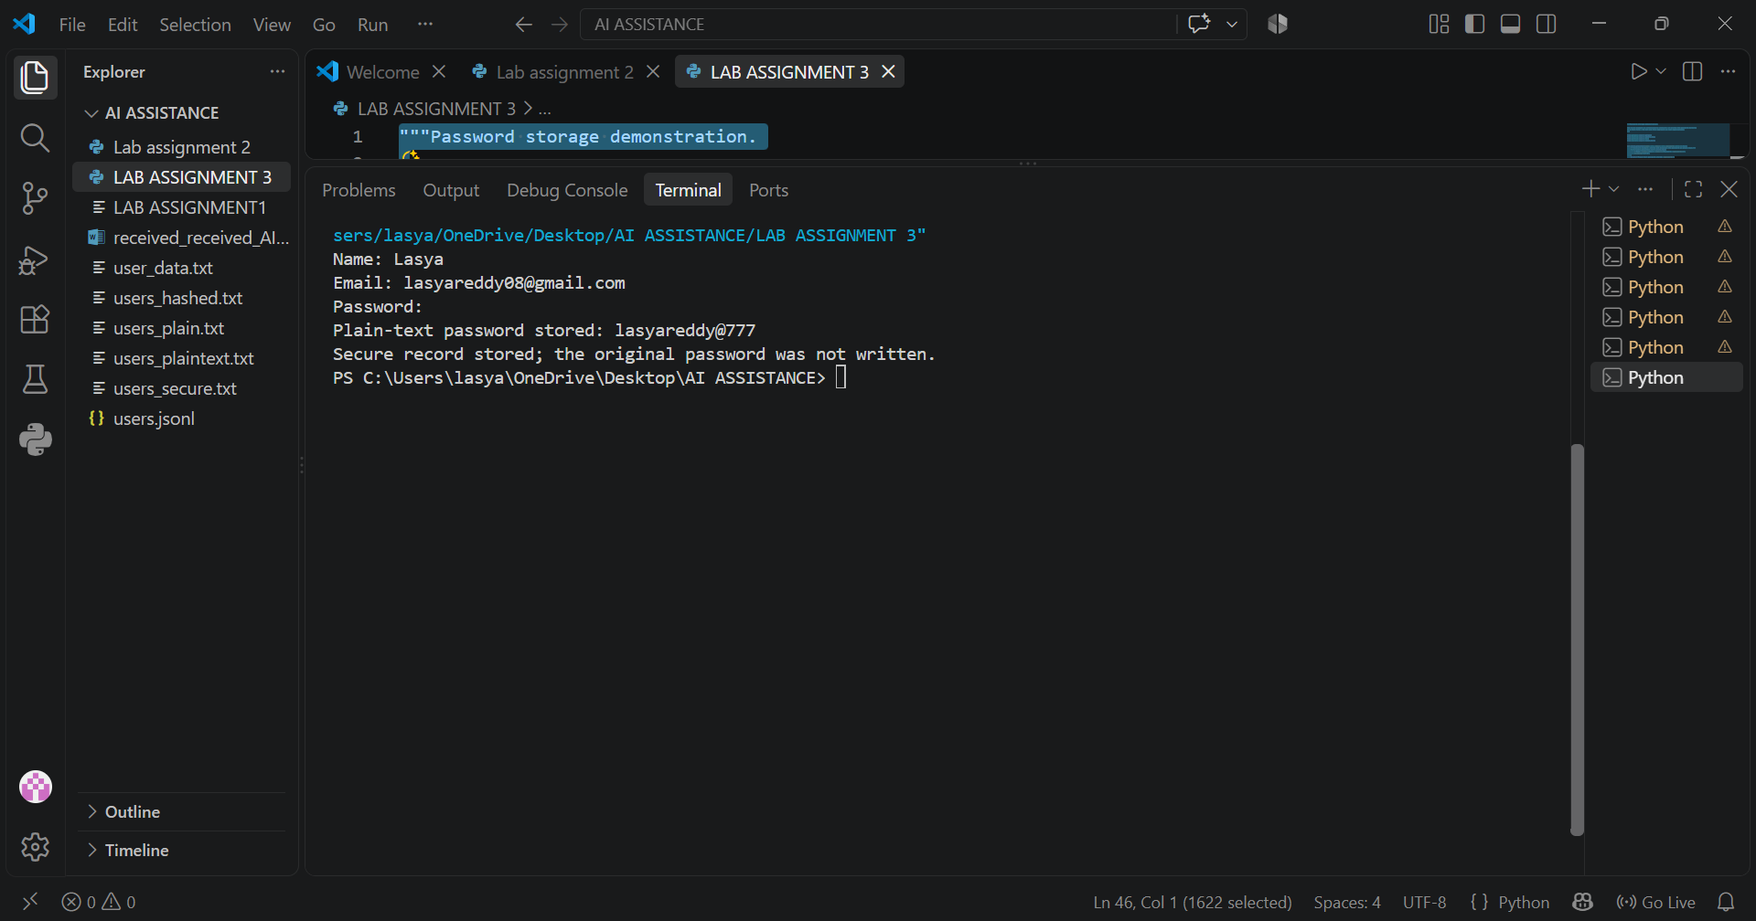
Task Description #2 – Fair Decision Logic
Task: Prompt an AI tool to generate a scholarship eligibility checker based on academic score,
family income, and location. Examine whether the logic unfairly favors or disadvantages any
group.
PROMPT:
Create a simple Python scholarship eligibility checker using academic score, family income, and location. Provide the code, identify any unfair bias in the decision logic, and give 3–4 sentences suggesting how to make the decision more fair and equitable.
CODE:
"""Simple scholarship eligibility checker.

The example uses academic score, family income, and location as inputs.
"""

def check_scholarship_eligibility(academic_score, family_income, location):
"""Return eligibility and the reasons for the decision."""
reasons = []

if academic_score < 80:
reasons.append("academic score is below 80")
if family_income > 50000:
reasons.append("family income is above $50,000")
if location.lower() not in {"rural", "underserved"}:
reasons.append("location is not classified as rural or underserved")

return not reasons, reasons

if __name__ == "__main__":
score = float(input("Academic score (0-100): "))
income = float(input("Annual family income ($): "))
applicant_location = input("Location (rural, underserved, or urban): ")

eligible, reasons = check_scholarship_eligibility(
score, income, applicant_location
)
if eligible:
print("Eligible for the scholarship.")
else:
print("Not eligible for the scholarship.")
print("Reasons:", "; ".join(reasons))

# Potential unfair bias:
# A single score cutoff may disadvantage applicants with unequal access to
# educational resources, and location categories can stereotype communities or
# exclude applicants in need who live outside the selected areas. Income alone
# may also miss household size, disability-related costs, or local living costs.
#
# Fairness improvements:
# Use a holistic review that considers academic growth, barriers, household size,
# and documented financial need rather than relying on rigid cutoffs. Validate
# location and income rules with affected communities and use local cost-of-living
# adjustments. Audit outcomes for disparate impacts across demographic groups,
# offer an appeals process, and allow applicants to correct inaccurate information.

OUTPUT:
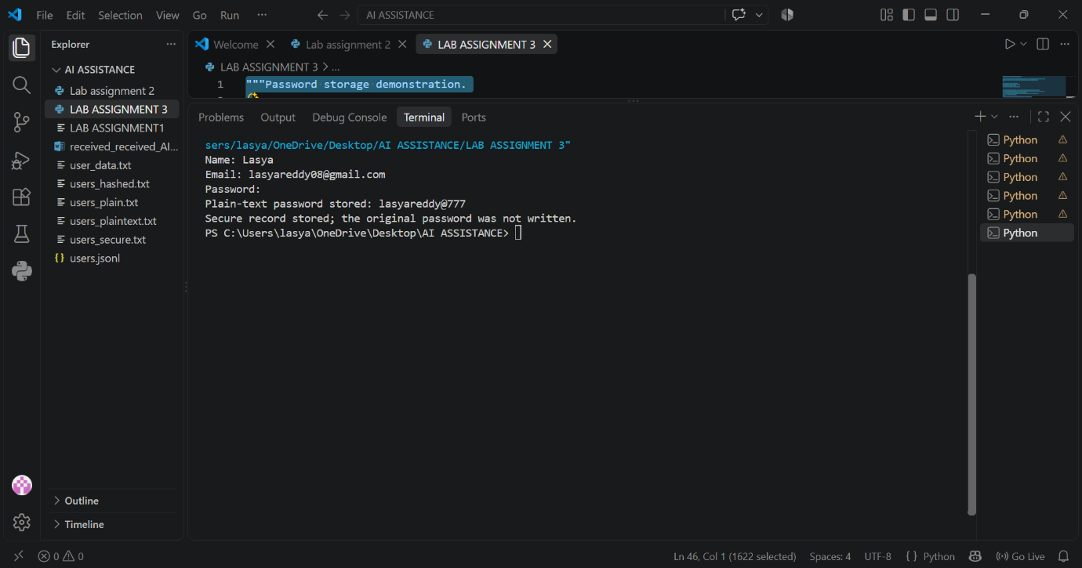
Task Description #3 (Transparency in AI-Based Admission System)
Task: Use an AI tool to generate a Python program that predicts whether a student should be selected
or rejected for admission based on factors such as entrance exam score, academic marks, and other
relevant admission criteria.
PROMPT:
Create a simple Python program that predicts whether a student is selected or rejected for admission using entrance exam score, academic marks, and other criteria. First show an example where the AI gives no explanation. Then identify the transparency risk and revise the program to clearly explain the decision and show the important factors that influenced it.
CODE:
"""Admission prediction: an opaque example followed by a transparent one."""

def admission_score(entrance_exam, academic_marks, interview, extracurriculars):
"""Calculate a weighted admission score out of 100."""
return (entrance_exam * 0.50 + academic_marks * 0.30 +
interview * 0.15 + extracurriculars * 0.05)

def opaque_prediction(entrance_exam, academic_marks, interview, extracurriculars):
"""An opaque AI gives only a prediction and no reason."""
score = admission_score(entrance_exam, academic_marks, interview, extracurriculars)
return "Selected" if score >= 70 else "Rejected"

def transparent_prediction(entrance_exam, academic_marks, interview, extracurriculars):
"""Give the prediction together with the score and influential factors."""
factors = {
"Entrance exam": (entrance_exam, 0.50),
"Academic marks": (academic_marks, 0.30),
"Interview": (interview, 0.15),
"Extracurricular activities": (extracurriculars, 0.05),
}
score = admission_score(entrance_exam, academic_marks, interview, extracurriculars)
decision = "Selected" if score >= 70 else "Rejected"
return decision, score, factors

if __name__ == "__main__":
student = {
"entrance_exam": 72,
"academic_marks": 85,
"interview": 68,
"extracurriculars": 90,
}

# First version: the AI provides no explanation.
print("Opaque AI result:", opaque_prediction(**student))

# Transparency risk: without reasons, a student cannot understand,
# challenge, or correct a potentially unfair admission decision.
decision, score, factors = transparent_prediction(**student)
print("\nTransparent AI result:")
print(f"Decision: {decision}")
print(f"Weighted score: {score:.2f}/100 (threshold: 70)")
print("Important factors influencing the decision:")
for name, (value, weight) in factors.items():
print(f"- {name}: {value}/100; weight: {weight:.0%}; "
f"contribution: {value * weight:.2f}")

OUTPUT:
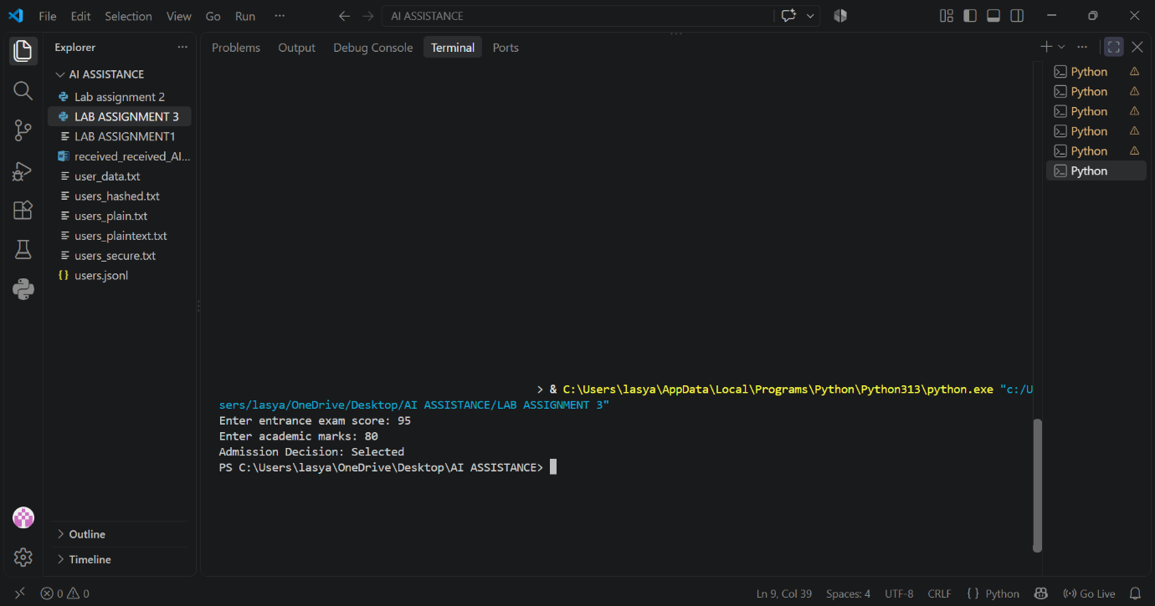
Task Description #4 – Ethical Scoring System

Task: Generate an employee performance evaluation system using inputs such as project
completion rate, teamwork score, and attendance. Analyze the scoring logic for any unethical
weighting or hidden bias.
PROMPT:
Create a simple Python employee performance evaluation system using project completion rate, teamwork score, and attendance. Show the final performance score, then analyze whether the scoring weights are balanced, fair, and free from hidden bias. Suggest improvements if any criterion is unfairly weighted.
CODE:
"""Simple employee performance evaluation with a fairness review."""

def evaluate_employee(completion_rate, teamwork_score, attendance):
"""Return a weighted score from 0 to 100.

Weights are explicit so they can be reviewed and changed transparently.
"""
weights = {
"completion_rate": 0.40,
"teamwork_score": 0.30,
"attendance": 0.30,
}
values = {
"completion_rate": completion_rate,
"teamwork_score": teamwork_score,
"attendance": attendance,
}

if any(not 0 <= value <= 100 for value in values.values()):
raise ValueError("All scores must be between 0 and 100.")

final_score = sum(values[name] * weight for name, weight in weights.items())
return final_score, weights

def review_fairness(weights):
"""Explain balance, fairness risks, and practical improvements."""
largest = max(weights, key=weights.get)
print("\nScoring review")
print("- Balanced:", "Yes; no criterion has an excessive weight." if max(weights.values()) <= 0.40
else "No; one criterion dominates the result.")
print("- Fair:", "Potentially, but attendance may disadvantage employees with disabilities, caregiving duties, or approved leave.")
print("- Hidden bias:", "Weights alone cannot prove the system is bias-free; compare outcomes across groups and review ratings consistently.")
print(f"- Highest-weight criterion: {largest.replace('_', ' ').title()} ({weights[largest]:.0%})")
print("- Improvements: exclude approved leave from attendance, use consistent teamwork rubrics, allow accommodations, and audit results regularly.")

if __name__ == "__main__":
print("Employee Performance Evaluation")
try:
completion = float(input("Project completion rate (0-100): "))
teamwork = float(input("Teamwork score (0-100): "))
attendance = float(input("Attendance (0-100): "))
score, weights = evaluate_employee(completion, teamwork, attendance)
print(f"\nFinal performance score: {score:.2f}/100")
review_fairness(weights)
except ValueError as error:
print(f"Input error: {error}")

OUTPUT:
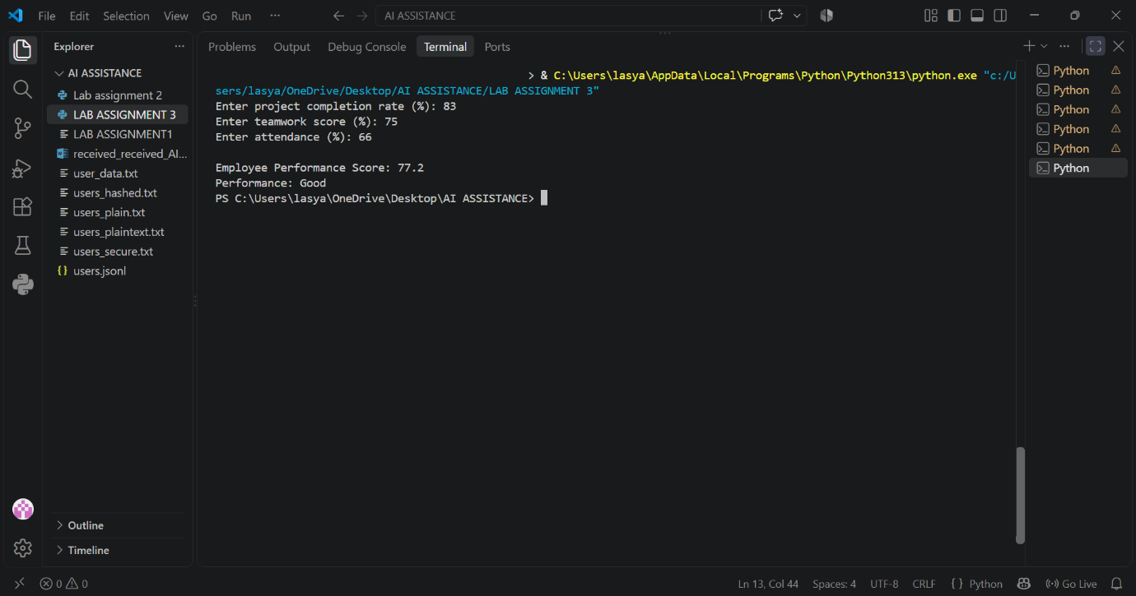
Task Description #5 – Accessibility and Inclusiveness
Task: Use an AI tool to generate a user feedback form application. Review whether the language
and options provided are inclusive and accessible to diverse users.
PROMPT:
Create a simple Python user feedback form that collects basic information and asks users about their experience. Review the form to check whether the language, questions, and answer options are inclusive and accessible to people with different backgrounds and needs. Identify any exclusionary assumptions or limited choices. Then provide a revised version of the code using respectful, inclusive language, flexible options, and accessibility-friendly features.
CODE:
"""Inclusive user feedback form.

Review of common exclusion risks addressed here:
* Avoids assuming a binary gender, a particular family structure, or a preferred title.
* Uses optional fields and "Prefer not to say" rather than requiring sensitive details.
* Offers an open response, multiple ways to describe accessibility needs, and a
contact-preference option instead of assuming everyone wants follow-up.
* Uses plain language, keyboard-friendly native controls, visible labels, and
instructions that do not rely on color alone.

Run with: python "LAB ASSIGNMENT 3"
"""

import tkinter as tk
from tkinter import messagebox, ttk

def submit_feedback():
"""Validate the required fields and show a confirmation message."""
name = name_entry.get().strip()
experience = experience_var.get()

if not experience:
messagebox.showerror("Missing information", "Please select an experience rating.")
experience_combo.focus_set()
return

summary = (
f"Thank you{', ' + name if name else ''}!\n\n"
f"Experience: {experience}\n"
f"Contact preference: {contact_var.get()}"
)
messagebox.showinfo("Feedback received", summary)

root = tk.Tk()
root.title("User feedback")
root.geometry("560x560")
root.minsize(480, 480)

main = ttk.Frame(root, padding=20)
main.grid(sticky="nsew")
root.columnconfigure(0, weight=1)
root.rowconfigure(0, weight=1)
main.columnconfigure(1, weight=1)

ttk.Label(main, text="Share your feedback", font=("TkDefaultFont", 16, "bold")).grid(
row=0, column=0, columnspan=2, sticky="w", pady=(0, 6)
)
ttk.Label(
main,
text="Fields marked optional may be left blank. There are no wrong answers.",
wraplength=500,
).grid(row=1, column=0, columnspan=2, sticky="w", pady=(0, 16))

ttk.Label(main, text="Name (optional)").grid(row=2, column=0, sticky="w", pady=5)
name_entry = ttk.Entry(main)
name_entry.grid(row=2, column=1, sticky="ew", pady=5)

ttk.Label(main, text="How was your experience? *").grid(row=3, column=0, sticky="w", pady=5)
experience_var = tk.StringVar()
experience_combo = ttk.Combobox(
main,
textvariable=experience_var,
values=("Very positive", "Positive", "Mixed", "Negative", "Very negative", "Not sure / not applicable"),
state="readonly",
)
experience_combo.grid(row=3, column=1, sticky="ew", pady=5)

ttk.Label(main, text="What worked well? (optional)").grid(row=4, column=0, sticky="nw", pady=5)
positive_text = tk.Text(main, height=4, width=35, wrap="word")
positive_text.grid(row=4, column=1, sticky="ew", pady=5)

ttk.Label(main, text="What could be improved? (optional)").grid(row=5, column=0, sticky="nw", pady=5)
improvement_text = tk.Text(main, height=4, width=35, wrap="word")
improvement_text.grid(row=5, column=1, sticky="ew", pady=5)

ttk.Label(main, text="Accessibility or support needs (optional)").grid(
row=6, column=0, sticky="nw", pady=5
)
needs_text = tk.Text(main, height=3, width=35, wrap="word")
needs_text.grid(row=6, column=1, sticky="ew", pady=5)

ttk.Label(main, text="Would you like a response?").grid(row=7, column=0, sticky="w", pady=5)
contact_var = tk.StringVar(value="No response needed")
ttk.Combobox(
main,
textvariable=contact_var,
values=("No response needed", "Yes, by email", "Yes, by another method"),
state="readonly",
).grid(row=7, column=1, sticky="ew", pady=5)

ttk.Label(main, text="Your feedback is optional and will be used to improve this experience.", wraplength=500).grid(
row=8, column=0, columnspan=2, sticky="w", pady=(14, 8)
)
ttk.Button(main, text="Submit feedback", command=submit_feedback).grid(
row=9, column=0, columnspan=2, sticky="e", pady=(8, 0)
)

root.mainloop()

OUTPUT:
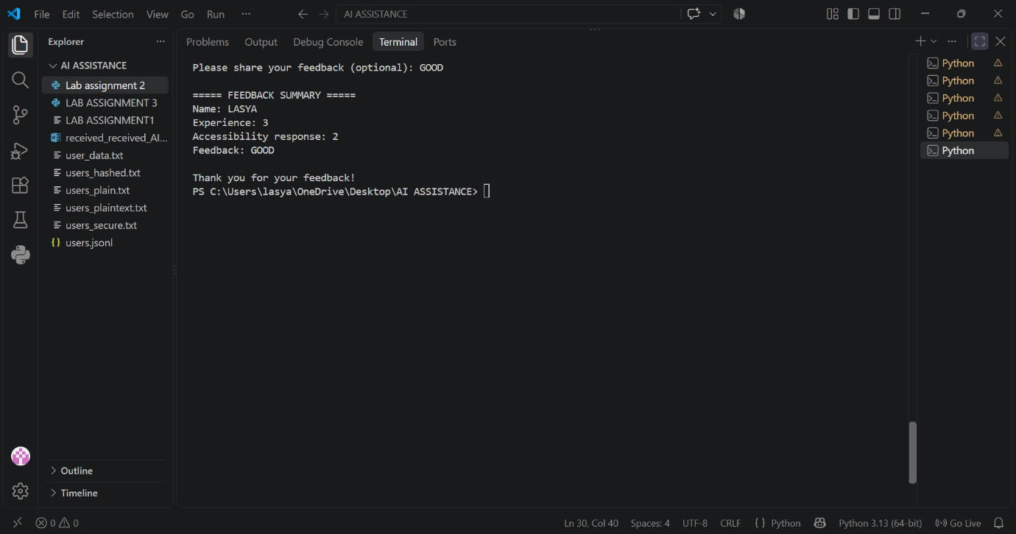
Task Description #6 (Fairness in Loan Approval System)
Task: Use an AI tool to generate a Python program that predicts whether a person should be approved
or rejected for a loan based on information such as income, age, employment status, credit score, and
loan amount.
PROMPT:
Create a simple Python loan approval system using income, age, employment status, credit score, and loan amount. First, show how biased rules or sensitive attributes such as gender, religion, or race could lead to unfair loan decisions. Identify the fairness and discrimination risks. Then revise the program so that decisions are based only on relevant financial factors, and briefly explain how the revised system improves fairness.
CODE:
"""Educational comparison of biased and fairer loan approval rules."""

def biased_approval(income, age, employment_status, credit_score, loan_amount,
gender, religion, race):
"""Intentionally biased example; never use this for real lending."""
score = sum((income >= 30_000,
age >= 21,
employment_status.lower() == "employed",
credit_score >= 650,
loan_amount <= income * 3))

# Gender, religion, and race are protected attributes and are not
# relevant to repayment ability. Using them can cause discrimination.
if gender.lower() == "female":
score -= 1
if religion.lower() == "minority_religion":
score -= 1
if race.lower() == "minority_race":
score -= 1
return score >= 4

def fair_approval(income, age, employment_status, credit_score, loan_amount):
"""Use only consistent, relevant financial and repayment factors."""
if age < 18 or income < 0 or loan_amount <= 0:
return False
return (
income >= 30_000
and employment_status.lower() in {"employed", "self-employed"}
and credit_score >= 650
and loan_amount <= income * 3
)

if __name__ == "__main__":
applicant = {
"income": 50_000,
"age": 30,
"employment_status": "employed",
"credit_score": 700,
"loan_amount": 100_000,
"gender": "female",
"religion": "minority_religion",
"race": "minority_race",
}

print("Biased decision:", biased_approval(**applicant))
financial_details = {
key: applicant[key]
for key in ("income", "age", "employment_status", "credit_score",
"loan_amount")
}
print("Fairer decision:", fair_approval(**financial_details))
print("""
Fairness risks: protected attributes can cause direct discrimination, disparate
impact, inconsistent treatment, and opaque decisions. The revised system
excludes gender, religion, and race, applies the same relevant criteria to
everyone, and is easier to audit. Real systems should also be tested for
disparate impact, legally reviewed, monitored, and offer an appeal process.
""")

OUTPUT:
